Ideation Phase
Empathize & Discover

Date | 08 July 2026
Team ID
Project Name | Sports Hall Booking System
Maximum Marks | 4 Marks

Empathy Map Canvas:
For the Sports Hall Booking System, the empathy map focuses on students and sports facility users who require a simple, reliable, and efficient method to reserve sports halls. By analyzing what users think, feel, see, say, do, hear, and experience, the system was designed to provide a user-friendly online booking platform through the ServiceNow Service Portal. This approach ensures improved convenience, minimizes booking conflicts, enhances transparency, and delivers a better overall booking experience..
Example:
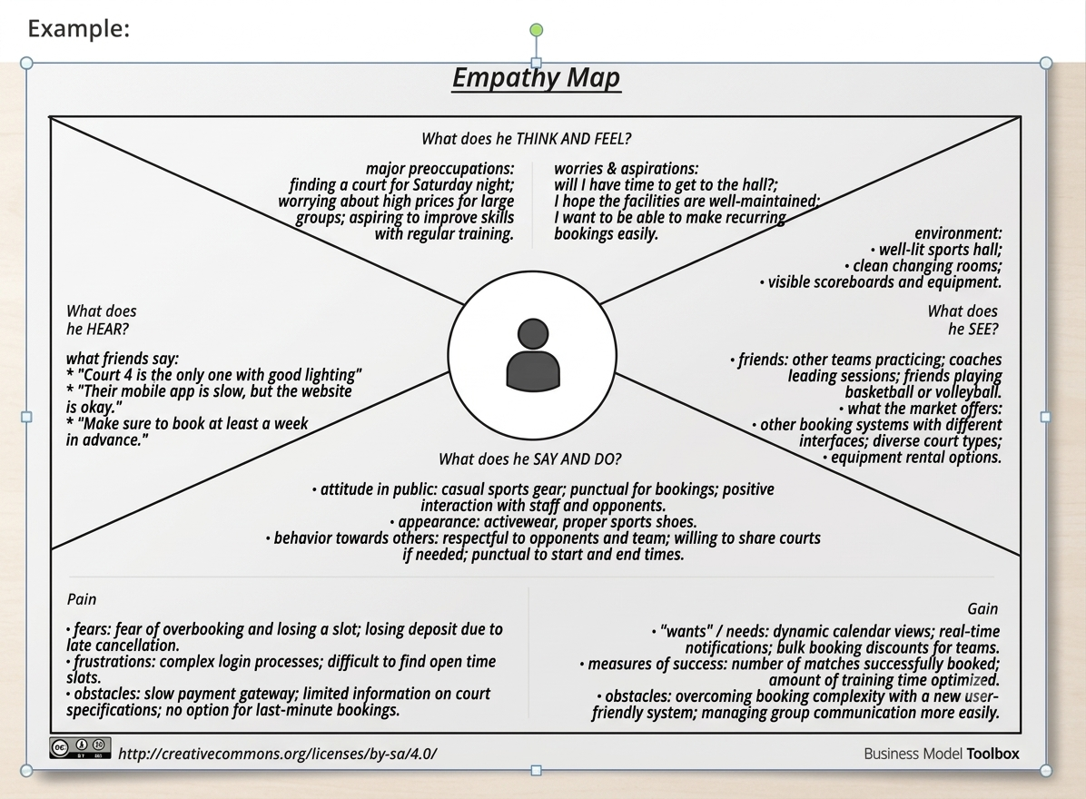

THINK & FEEL
---------------------------------------------------------
| Is the hall available? |
| I need quick booking |
| Avoid booking conflicts |
| Why can't I book online? |
| Need instant confirmation |
---------------------------------------------------------
HEAR SEE
-------------------- -------------------------
Ask coordinator Manual register
Hall already booked Sports notice board
Visit sports office Students waiting
Use Sports Portal Available time slots
-------------------- -------------------------
SAY & DO
---------------------------------------------------------
Book Basketball Hall
Check available slots
Reserve evening slot
View my bookings
Booking successful
---------------------------------------------------------
PAIN GAIN
-------------------------- ----------------------------
Manual booking Online booking
Double bookings Real-time slots
Time consuming Instant confirmation
No transparency Easy reservation
Visit office Better user experience

